Test Case: tc002_SPX_Dev5_Crear_Requisicion_Spot_Con_FAD_Tipo_Cobro_CC
Step 1 - Enter username and password and click to button Enter : Credentials Entered
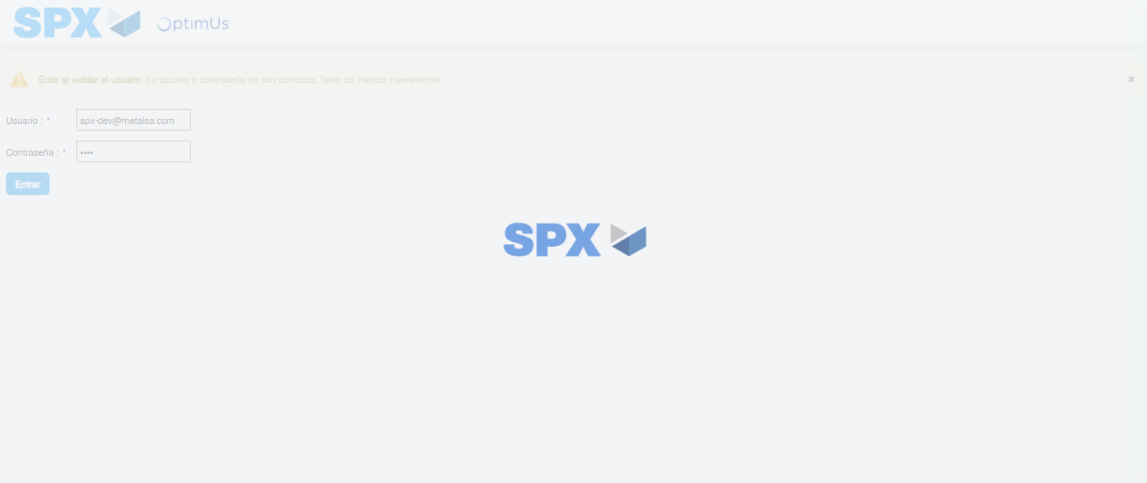Image file-name: QC_Testing-tc002_SPX_Dev5_Crear_Requisicion_Spot_Con_FAD_Tipo_Cobro_CC-1785975570257

Step 2 - Select to UEN and Access to Spot Buy Requisitions : UEN Correctly selected and Correct access
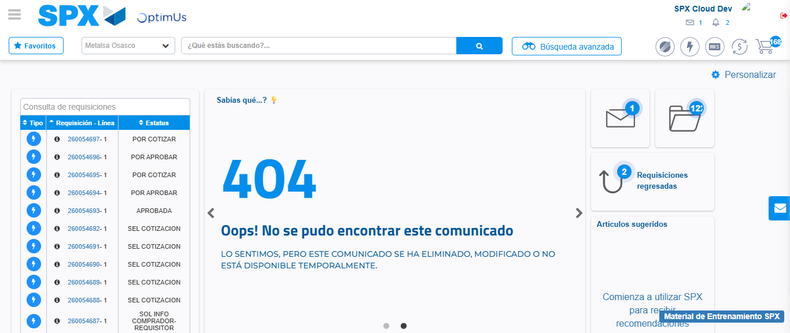Image file-name: QC_Testing-tc002_SPX_Dev5_Crear_Requisicion_Spot_Con_FAD_Tipo_Cobro_CC-1785975596823

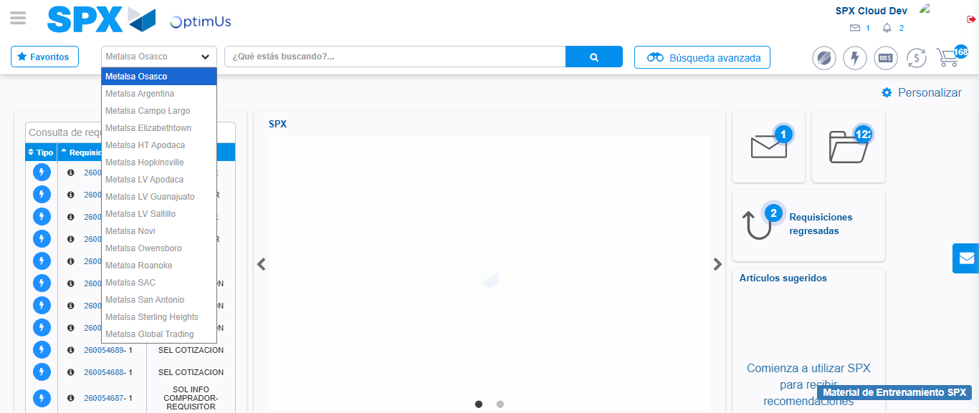Image file-name: QC_Testing-tc002_SPX_Dev5_Crear_Requisicion_Spot_Con_FAD_Tipo_Cobro_CC-1785975599749

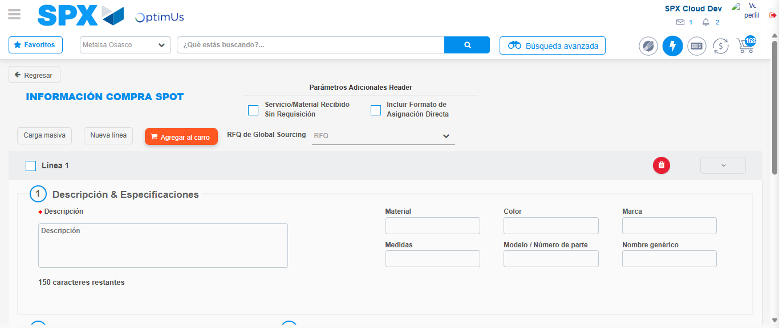Image file-name: QC_Testing-tc002_SPX_Dev5_Crear_Requisicion_Spot_Con_FAD_Tipo_Cobro_CC-1785975606752

Step 3 - Add FAD to Requisition: FAD Successfully Added
Image file-name: QC_Testing-tc002_SPX_Dev5_Crear_Requisicion_Spot_Con_FAD_Tipo_Cobro_CC-1785975607020

Image file-name: QC_Testing-tc002_SPX_Dev5_Crear_Requisicion_Spot_Con_FAD_Tipo_Cobro_CC-1785975607234

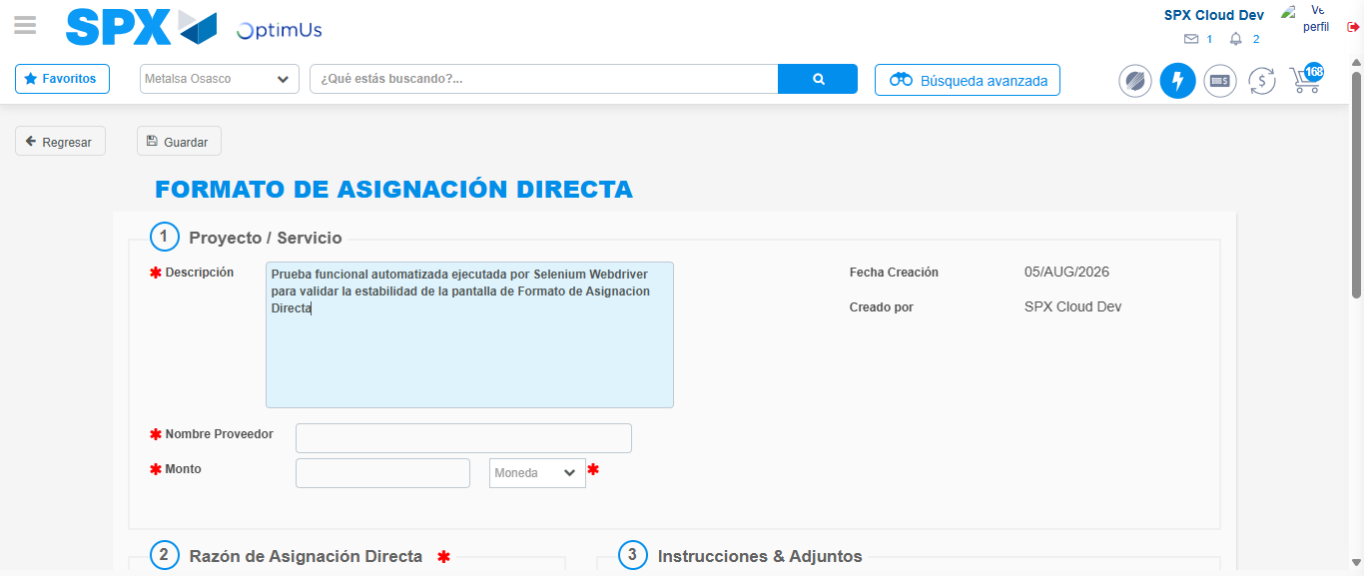Image file-name: QC_Testing-tc002_SPX_Dev5_Crear_Requisicion_Spot_Con_FAD_Tipo_Cobro_CC-1785975610209

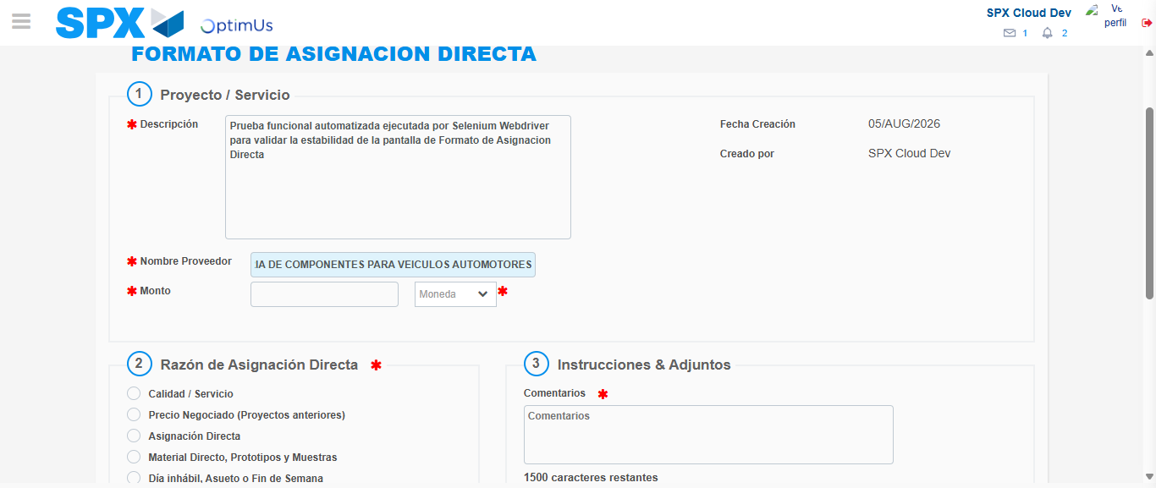Image file-name: QC_Testing-tc002_SPX_Dev5_Crear_Requisicion_Spot_Con_FAD_Tipo_Cobro_CC-1785975620320

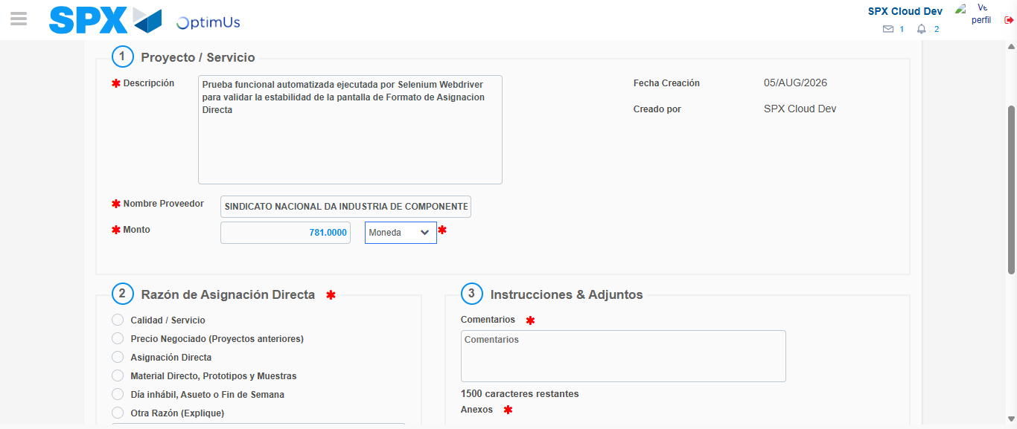Image file-name: QC_Testing-tc002_SPX_Dev5_Crear_Requisicion_Spot_Con_FAD_Tipo_Cobro_CC-1785975620826

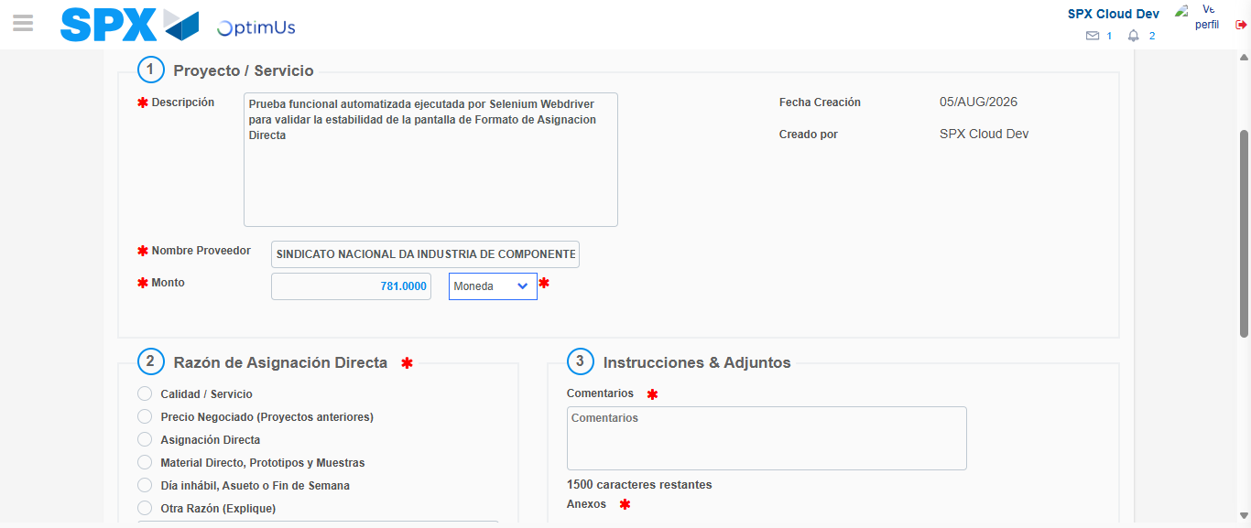Image file-name: QC_Testing-tc002_SPX_Dev5_Crear_Requisicion_Spot_Con_FAD_Tipo_Cobro_CC-1785975621046

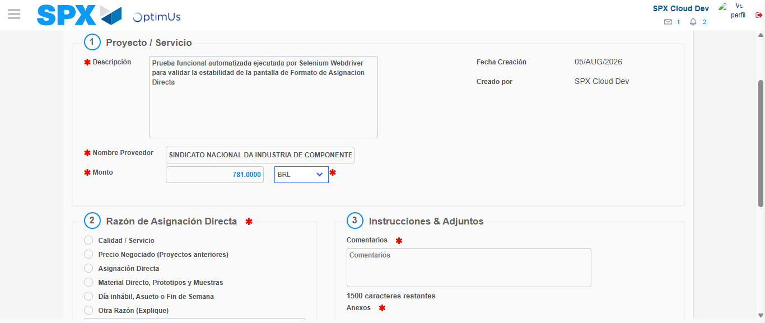Image file-name: QC_Testing-tc002_SPX_Dev5_Crear_Requisicion_Spot_Con_FAD_Tipo_Cobro_CC-1785975621629

Image file-name: QC_Testing-tc002_SPX_Dev5_Crear_Requisicion_Spot_Con_FAD_Tipo_Cobro_CC-1785975621844

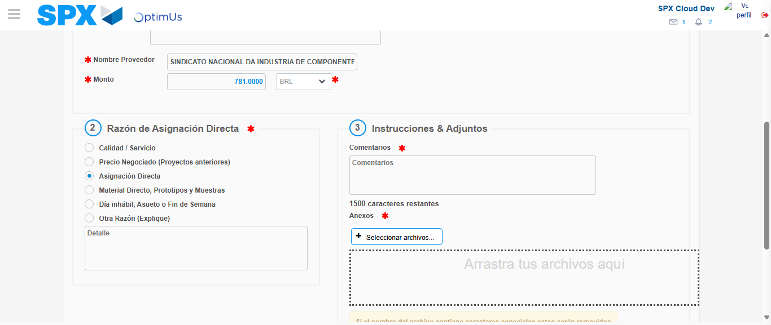Image file-name: QC_Testing-tc002_SPX_Dev5_Crear_Requisicion_Spot_Con_FAD_Tipo_Cobro_CC-1785975622843

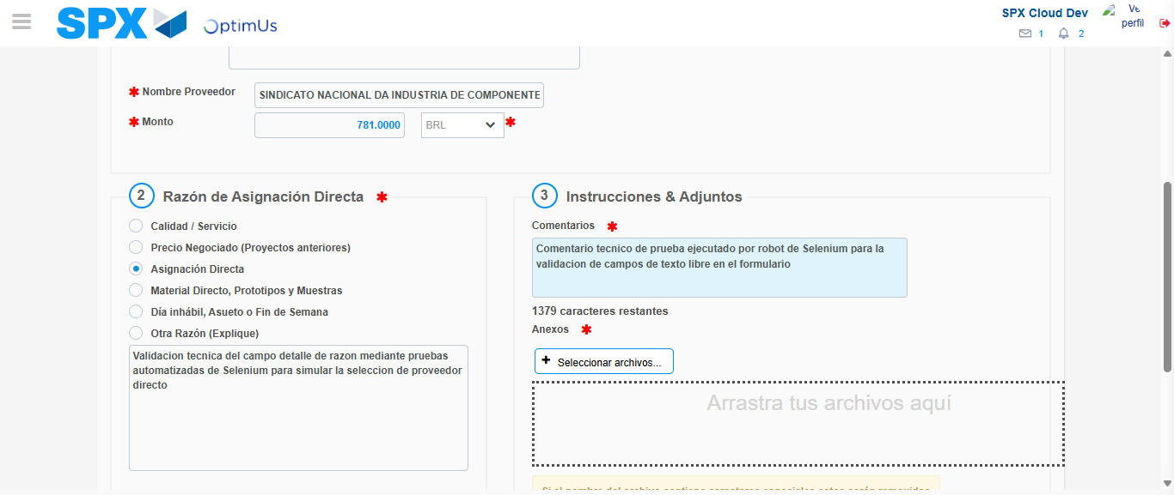Image file-name: QC_Testing-tc002_SPX_Dev5_Crear_Requisicion_Spot_Con_FAD_Tipo_Cobro_CC-1785975634284

Image file-name: QC_Testing-tc002_SPX_Dev5_Crear_Requisicion_Spot_Con_FAD_Tipo_Cobro_CC-1785975635272

Step 4 - Data Capture Spot Buy Requisition: Data captured correctly
Image file-name: QC_Testing-tc002_SPX_Dev5_Crear_Requisicion_Spot_Con_FAD_Tipo_Cobro_CC-1785975607020

Image file-name: QC_Testing-tc002_SPX_Dev5_Crear_Requisicion_Spot_Con_FAD_Tipo_Cobro_CC-1785975607234

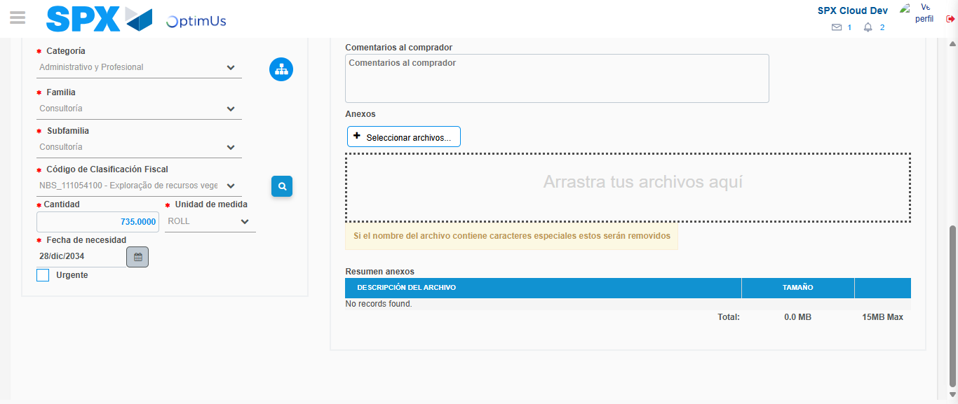Image file-name: QC_Testing-tc002_SPX_Dev5_Crear_Requisicion_Spot_Con_FAD_Tipo_Cobro_CC-1785975656627

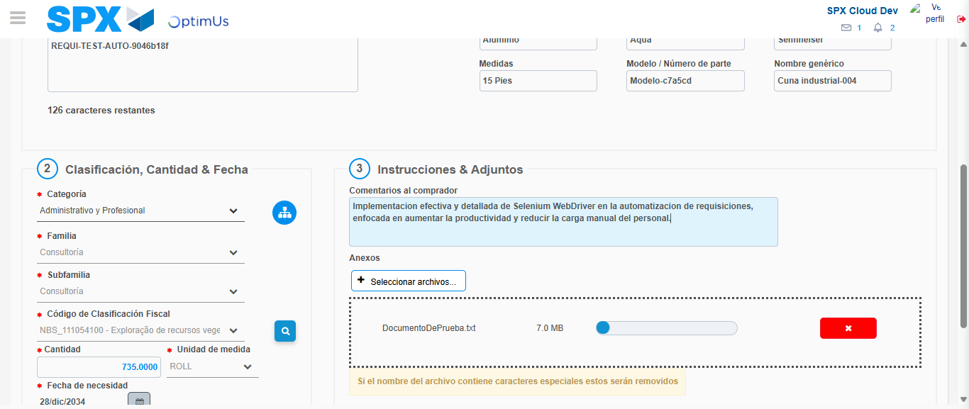Image file-name: QC_Testing-tc002_SPX_Dev5_Crear_Requisicion_Spot_Con_FAD_Tipo_Cobro_CC-1785975657649

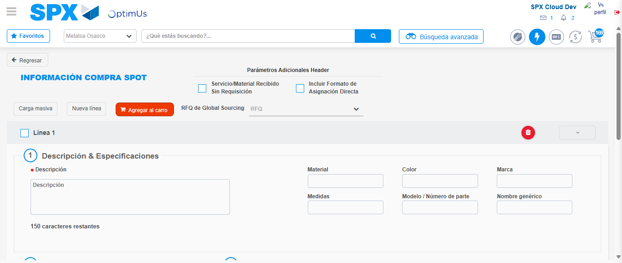Image file-name: QC_Testing-tc002_SPX_Dev5_Crear_Requisicion_Spot_Con_FAD_Tipo_Cobro_CC-1785975667651

Step 8 - Return to Main Page SPX : Return to Main Page SPX
Image file-name: QC_Testing-tc002_SPX_Dev5_Crear_Requisicion_Spot_Con_FAD_Tipo_Cobro_CC-1785975596823

Image file-name: QC_Testing-tc002_SPX_Dev5_Crear_Requisicion_Spot_Con_FAD_Tipo_Cobro_CC-1785975599749

Image file-name: QC_Testing-tc002_SPX_Dev5_Crear_Requisicion_Spot_Con_FAD_Tipo_Cobro_CC-1785975606752

Image file-name: QC_Testing-tc002_SPX_Dev5_Crear_Requisicion_Spot_Con_FAD_Tipo_Cobro_CC-1785975669933

Image file-name: QC_Testing-tc002_SPX_Dev5_Crear_Requisicion_Spot_Con_FAD_Tipo_Cobro_CC-1785975670123

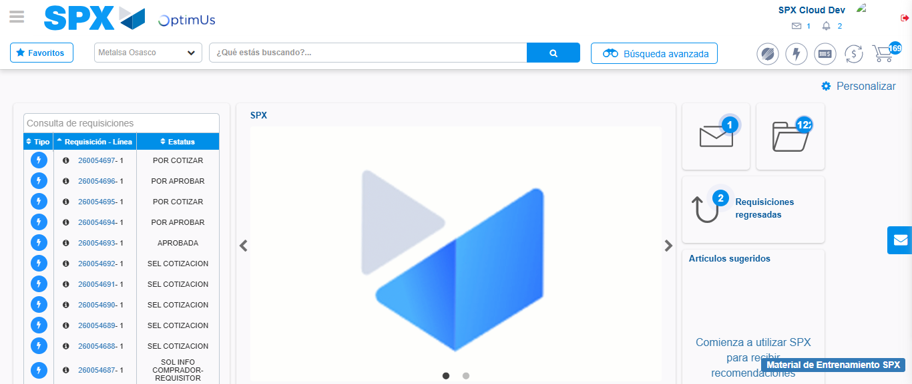Image file-name: QC_Testing-tc002_SPX_Dev5_Crear_Requisicion_Spot_Con_FAD_Tipo_Cobro_CC-1785975691656

Step 9 - Log Out : Log Out SPX
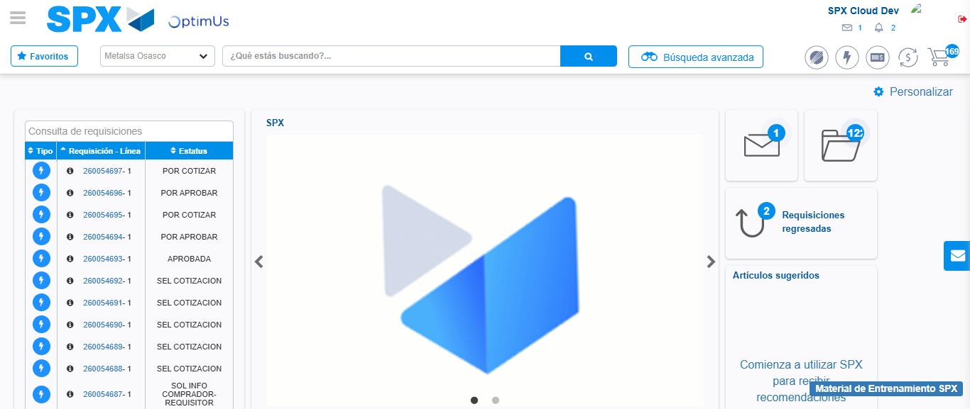Image file-name: QC_Testing-tc002_SPX_Dev5_Crear_Requisicion_Spot_Con_FAD_Tipo_Cobro_CC-1785975691931

